STEP 3 – File generation for Shorelines
3.0-) Open the file raw.bil on GM.
3.1-) The BIL file is ready to generate the SHP file for shoreline.
For Shoreline – With raw.bil still opened, generate the shorelines:
ANALYSIS – GENERATE CONTOURS (FROM TERRAIN GRID)…
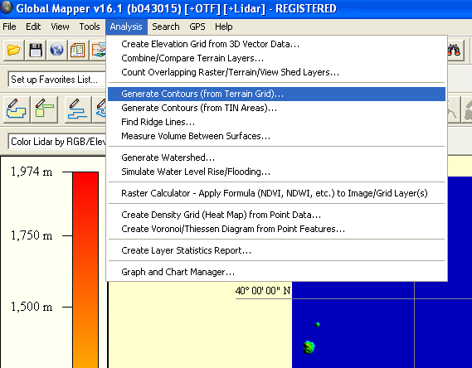
Edit the parameters of CONTOUR OPTIONS tab like following image.
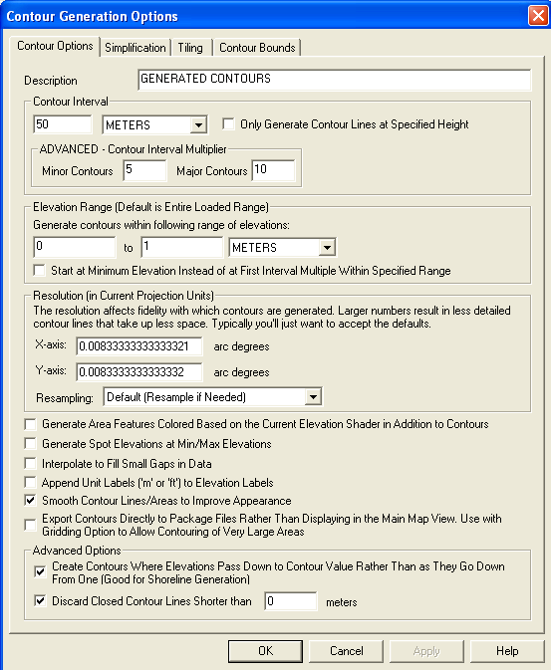
Select the SIMPLIFICATION tab.
Edit the parameters like following image. Click OK. GM will generate brown Shorelines.
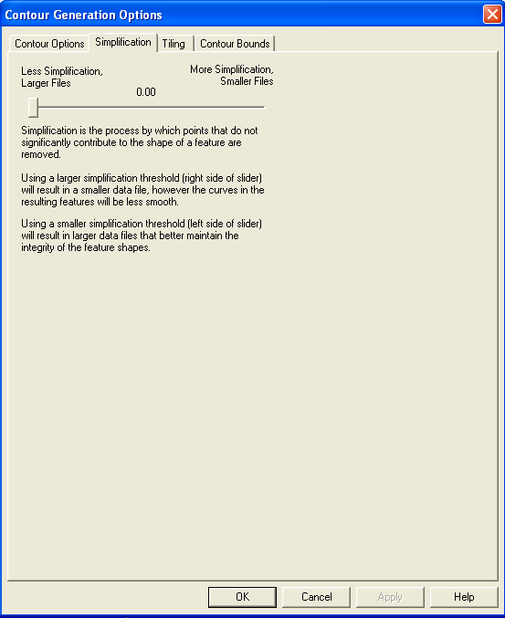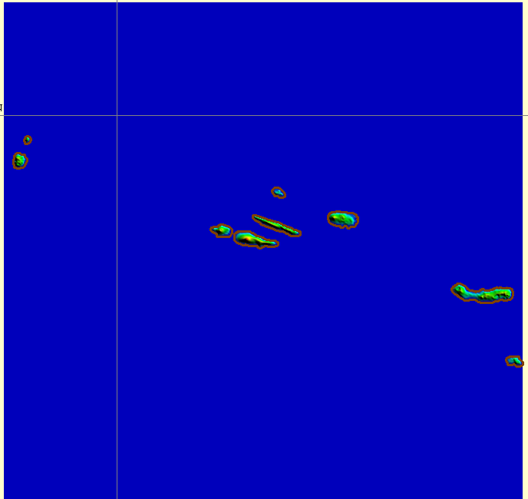
Export the shorelines in Shapefile format:
FILE – EXPORT – EXPORT VECTOR / LIDAR FORMAT…
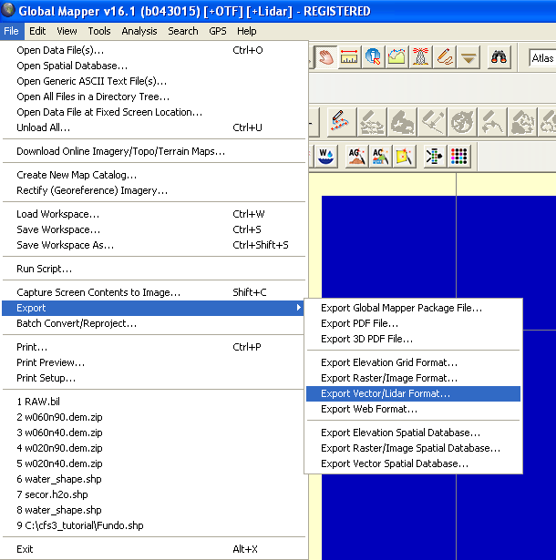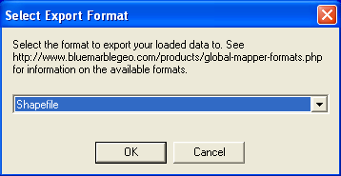

Click OK, a new parameters window will open.

Edit the parameters like following image. When you enable the EXPORT LINES box, a SAVE DIALOG window will open. Save the SHP file on your working dir with name like shoreline.shp. Click on SAVE.
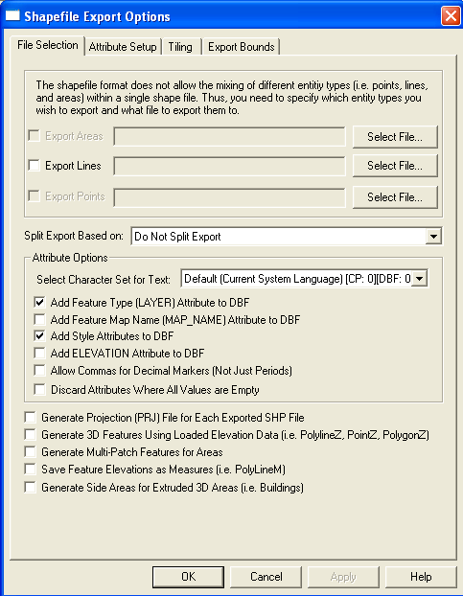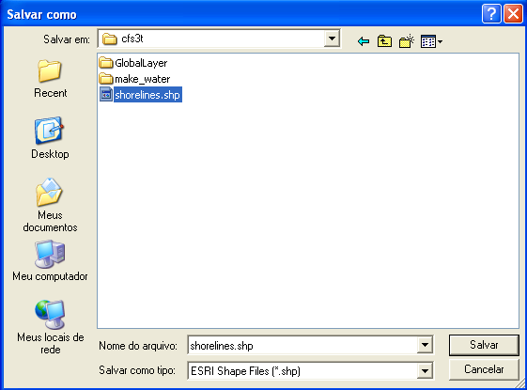

3.2-)Unload all data in GM:
FILE – UNLOAD ALL…
If GM want to save changes, Click NO:
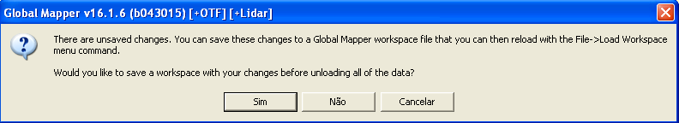

3.3-) End of STEP 3

